Company Name: Middle East Business Geotech LLC

Company Logo:

About Us:

Middle East Business Geotech LLC specialises in geotechnical engineering and construction, offering design and execution solutions for slope stabilisation, ground improvement, foundation engineering and underground works. Our expertise includes anchoring, shotcrete, rockfall protection, piling, grouting, tunnelling and infrastructure rehabilitation. With a focus on safety, quality and efficient execution, we deliver practical, durable solutions tailored to each project’s requirements.

Our Vision:
To be the most trusted name in specialized geotechnical engineering across Oman and the wider region — recognized for technical excellence, engineering integrity, and the safe, reliable execution of projects that protect infrastructure, communities, and the environment.

We aim to advance the practice of geotechnical construction in the Sultanate by bringing internationally recognized methods and standards to every project, while building local technical capability and long-term partnerships with the clients who rely on us.

Our Core Values

1. Engineering Integrity
We do not compromise on the technical fundamentals. Every anchor, bolt, pile, and grout column is designed and installed according to sound geotechnical principles"not shortcuts. Our reputation is built on getting the engineering right, every time.

2. Technical Precision
Geotechnical work leaves little room for error. We bring exacting standards, calibrated equipment, and disciplined execution to every project, because the ground doesn't forgive guesswork. This precision is independently verified through our *ISO 9001:2015* certified Quality Management System.

3. Safety & Employee Well-Being
Our people work on unstable slopes, deep excavations, and underground structures"environments where their safety has to come first, not last. We invest in rigorous training, certified PPE, regular site audits, and a culture where any worker can halt a task without question if something feels unsafe. Beyond physical safety, we care about the well-being of every employee"fair treatment, proper rest, and a workplace where people are valued, not just utilized. Our occupational health and safety practices are certified to *ISO 45001:2018*, reflecting a structured, internationally benchmarked approach to protecting the people who make our work possible.

4. Environmental Responsibility
Specialized ground engineering carries real environmental obligations—from managing grout and runoff on-site to minimizing our footprint on the surrounding land. Our processes are certified to *ISO 14001:2015* (Environmental Management), giving clients independently verified assurance that we operate responsibly, not just effectively.

5. Long-Term Partnership
We measure success not in single contracts but in 10+ years of repeat trust from clients including Galfar, Al Shanfari Contracting, Sarooj, and others across both government and private sectors. We build relationships designed to last, grounded in consistent performance, reliability under pressure, and accountability on every project.

Services:

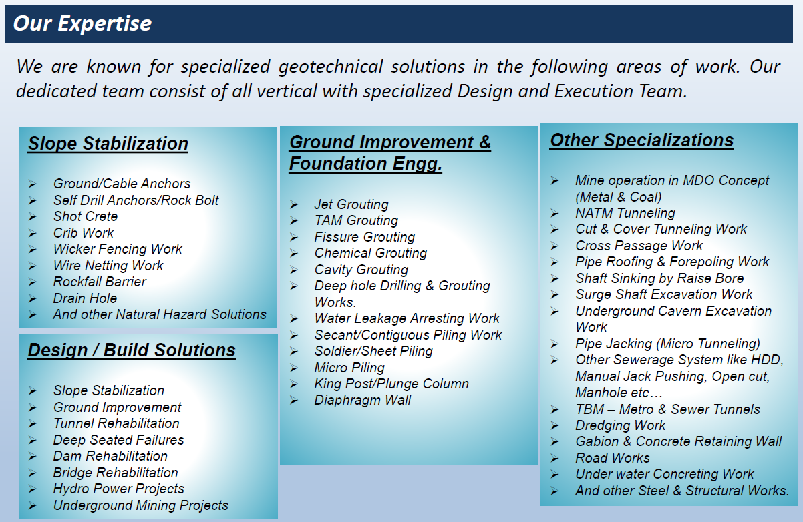
Contact Details:

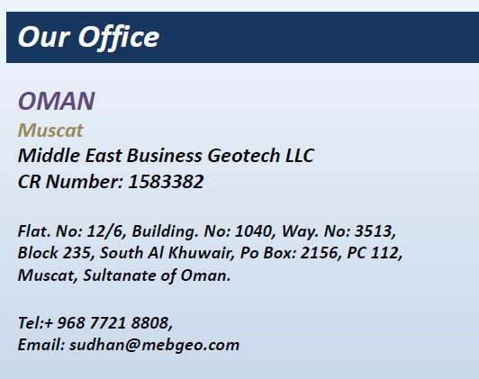

PROJECTS:

Ongoing Projects:

- Job place: Al Ubaidah to Fayyad Road – Buraimi Governorate, Oman
Client: MOTC – Al Tasnim Enterprises L.L.C
Nature of Work: Slope Protection Work – Shotcrete, Wire Netting, Ditch Lining & Rock Bolt.

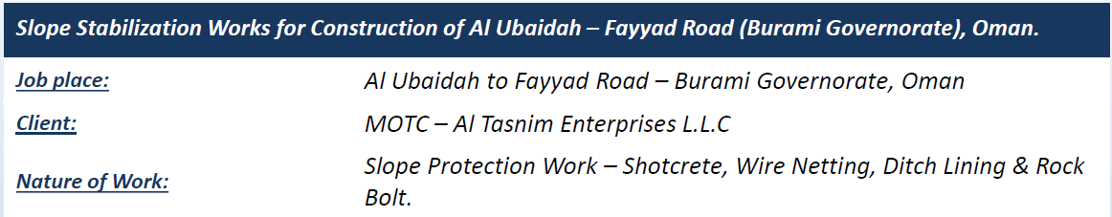

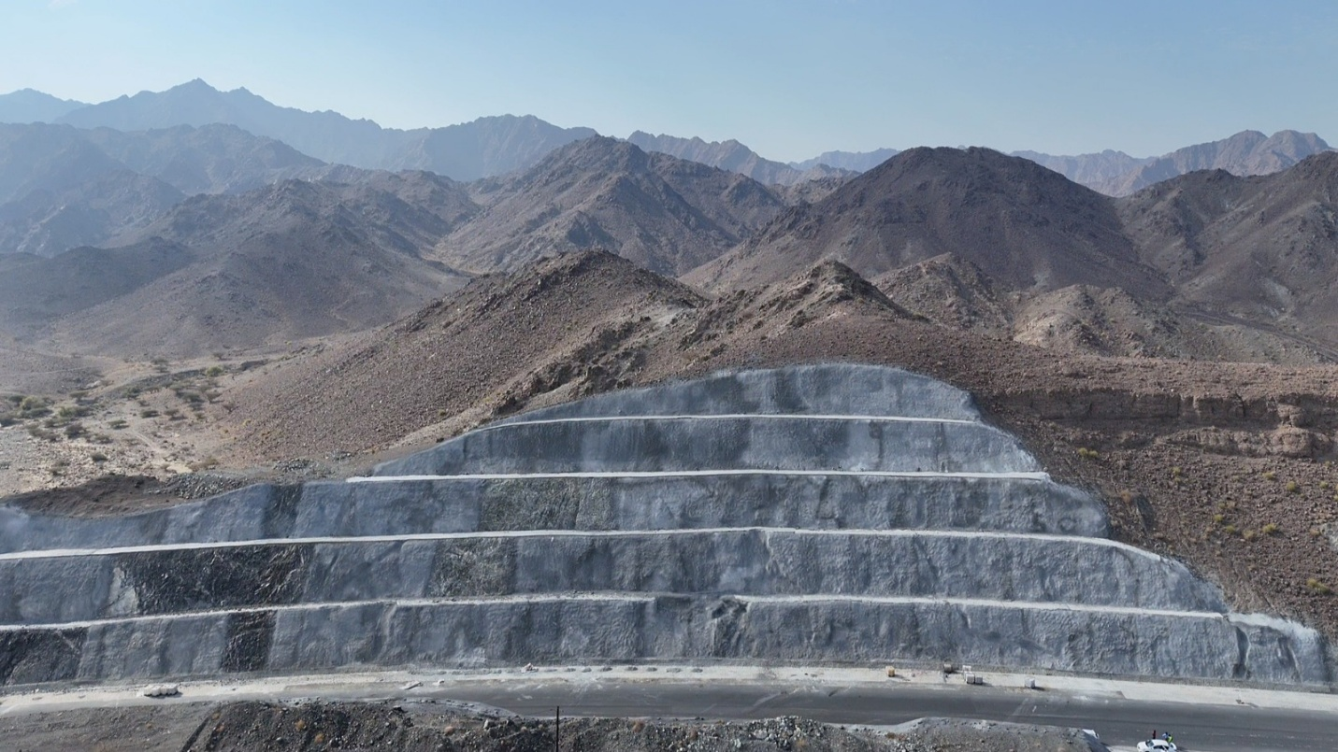

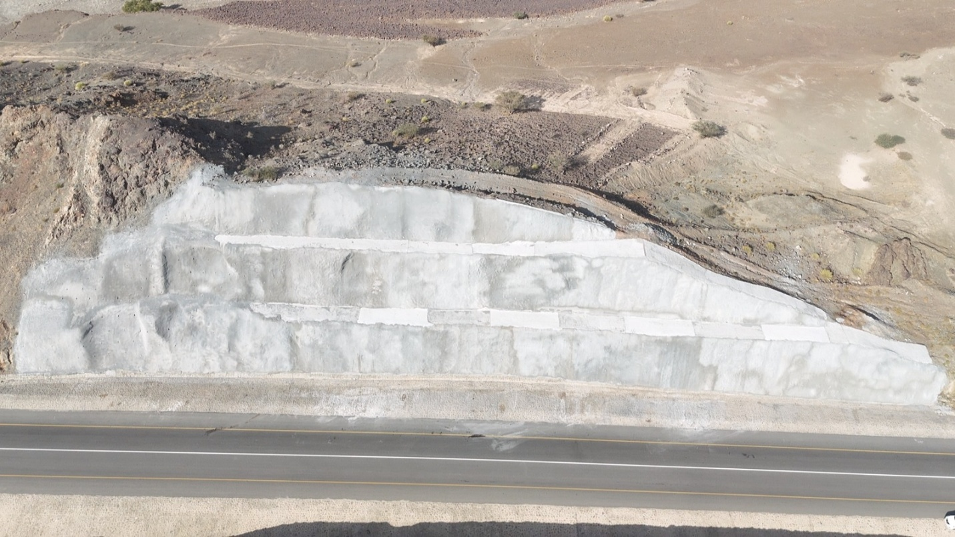

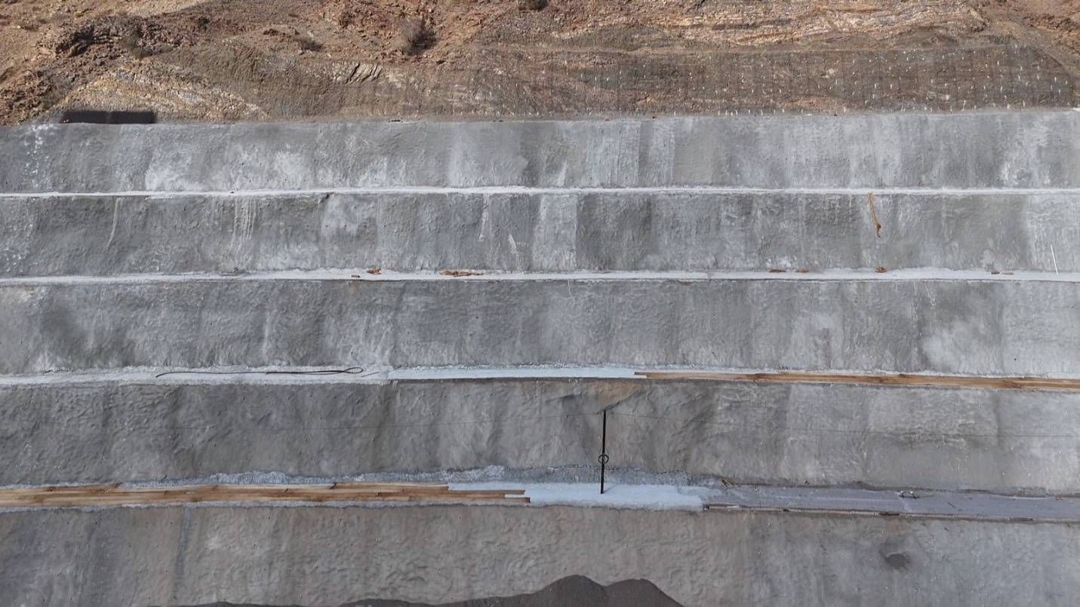

- Job Place: Khasab – Lima, Musandam Governorate, Oman
Client: MOTC – Sarooj Construction Company L.L.C
Nature of Work: Slope Protection Work – Wire netting, Rock Bolt & Rockfall Barrier.

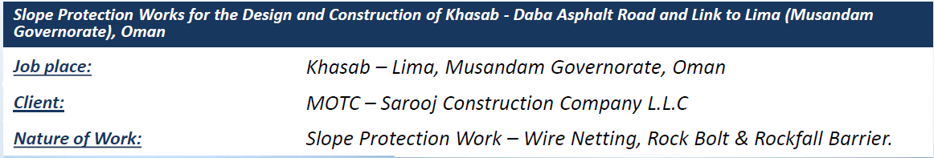

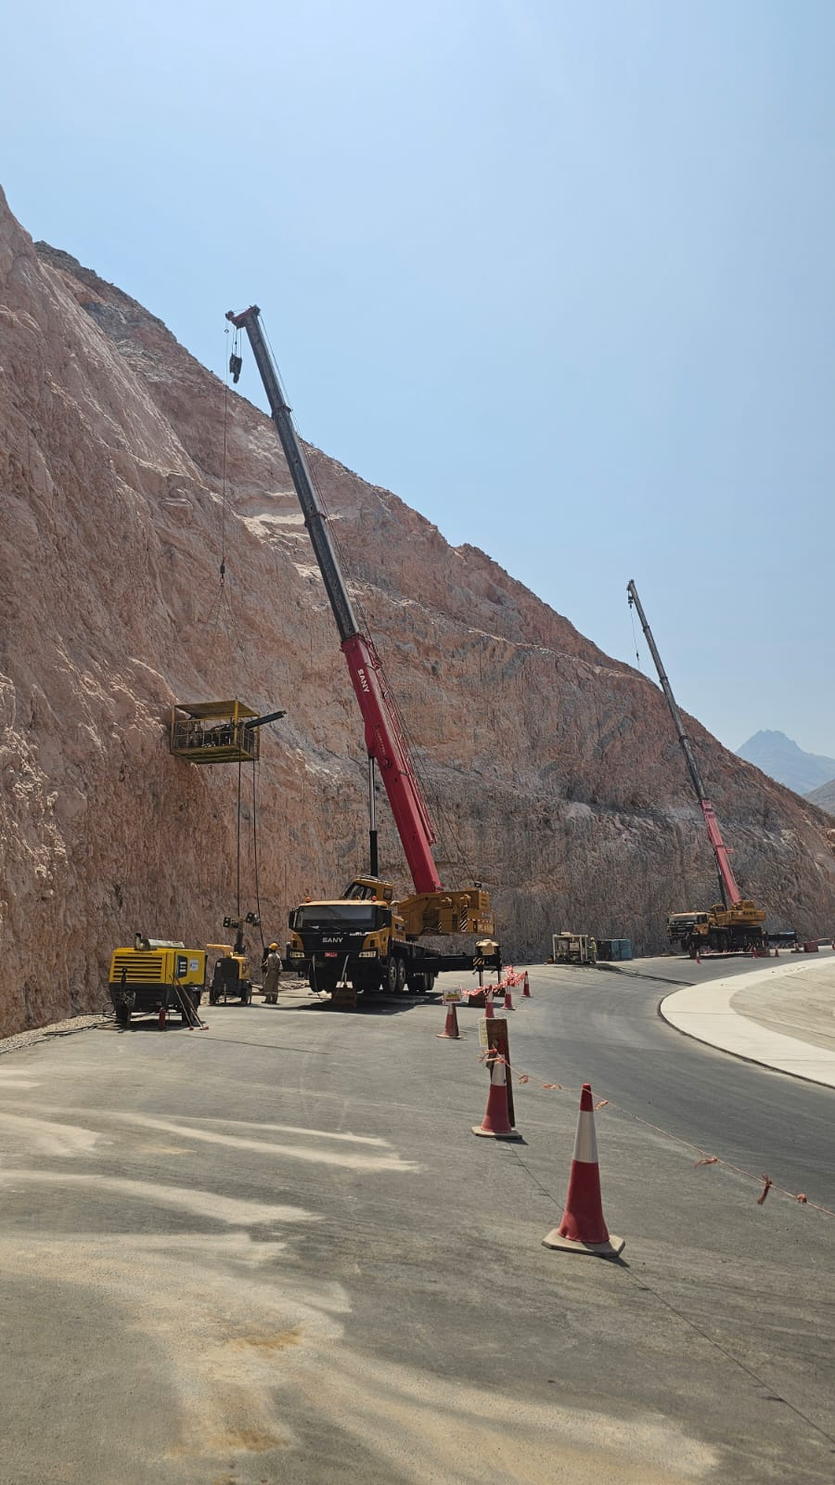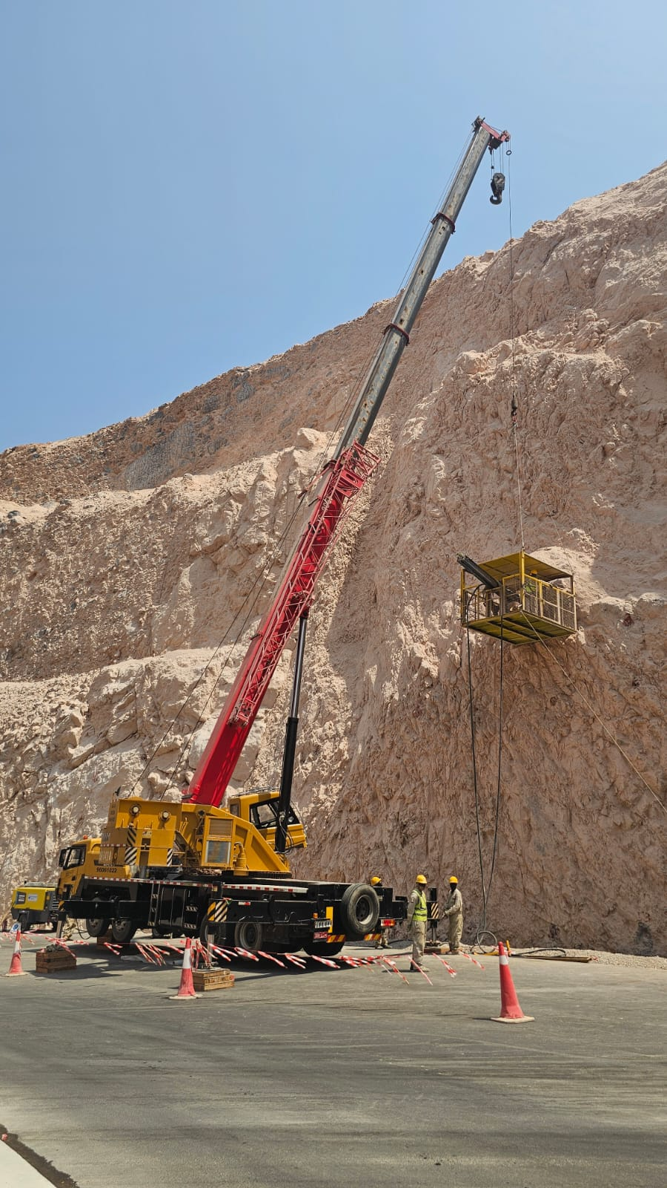

- Job Place: Wilayat Manah, Nizwa, Oman
Client: NAMA – Towell Infrastructure Projects Co L.L.C
Nature of Work: Slope Protection Work – Shotcrete, Wire netting, Ditch Lining & Rock bolt.

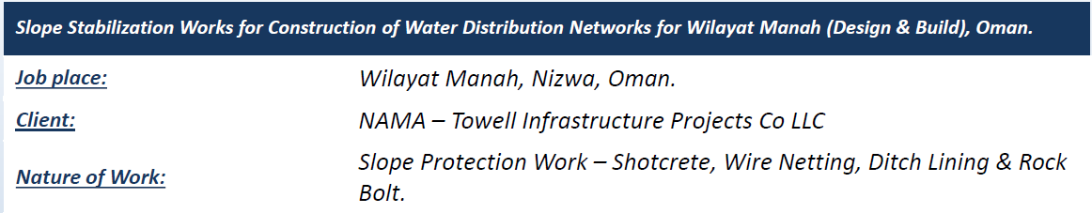

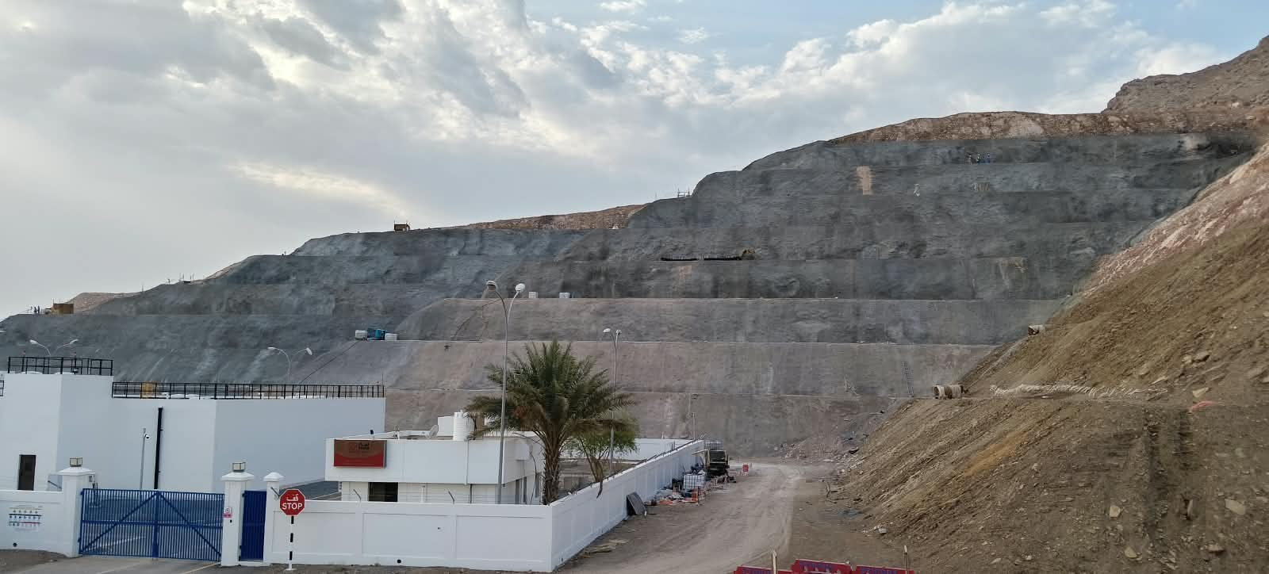

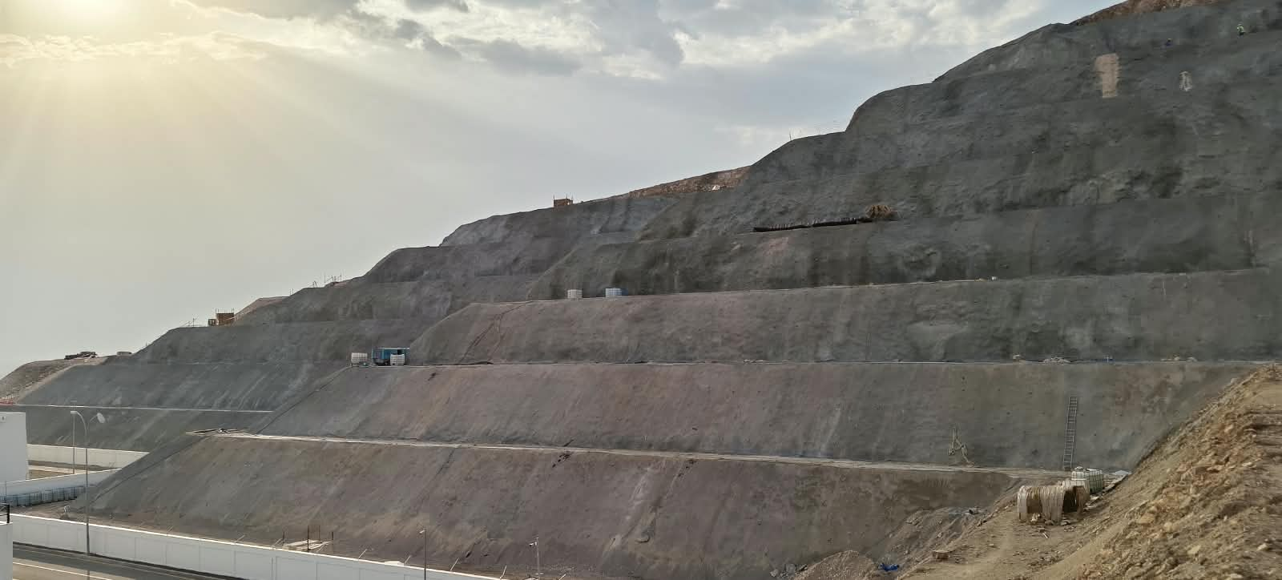

Completed Projects:

- Job Place: Al Kamil to Sur Road – Al Sharqiyah Expressway, Oman
Client: MOTC – Al Tasnim Enterprises L.L.C
Nature of Work: Slope Protection Work – Shotcrete, Wire netting, Ditch Lining & Rock bolt.

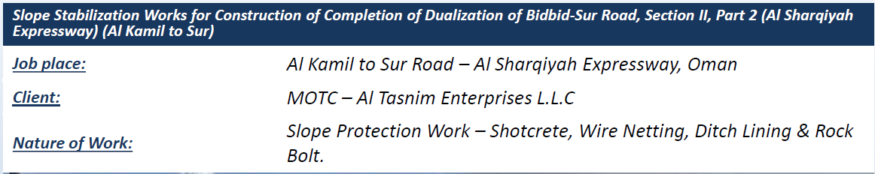

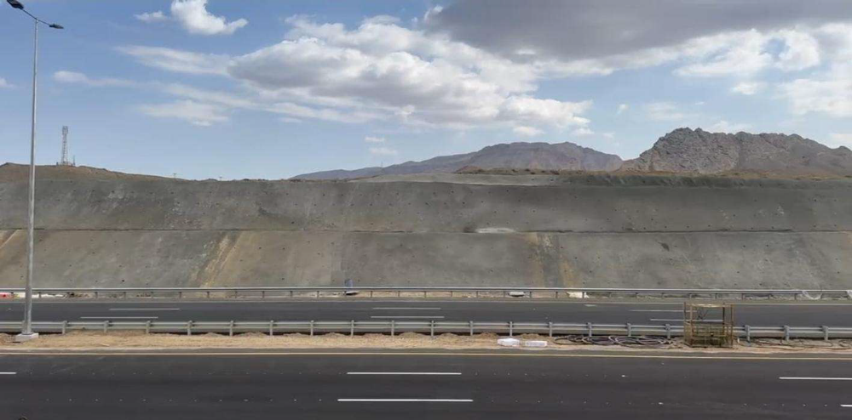

- Job Place: Al Sharqiyah Region, Oman
Client: NAMA – China Geo Engineering Corporation International Limited
Nature of Work: Slope Protection Work – Shotcrete, Wire netting, Bench Concrete & Rock bolt.

